**InsightStream: Navigate the News**

**Project Title: InsightStream**

**Team Members:**

|  |  |  |
| --- | --- | --- |
| **Team ID** | SWTID1741146769 |  |
| **Role** | **Name** | **Email** **ID** |
| Team Leader | Jayanthi N | jayanthidurai582@gmail.com |
| Team Member 1 | Kanimozhi K | kani2292004@gmail.com |
| Team Member 2 | Akchaya S B | akchayasaravanan@gmail.com |
| Team Member 3 | Abirami C | abi9840072@gmail.com |

## ****Project Overview****

### ****Purpose****

InsightStream is a revolutionary web application designed to redefine how users discover and consume news. The primary objective is to provide a user-friendly, efficient, and engaging platform where users can explore a wide range of news topics dynamically and interactively.

### ****Features****

* **Dynamic Search:** Users can quickly find news articles based on keywords and categories.
* **Trending News:** A dedicated section for the latest breaking news and popular stories.
* **Category-Based Browsing:** Users can explore news articles sorted into multiple categories.
* **Subscription & Notifications:** Users can subscribe for daily updates via email.
* **Clean UI/UX:** A visually appealing interface designed for a seamless user experience.

## ****Architecture****

### ****Component Structure****

The application is structured into multiple React components:

* **Navbar:** Navigation bar with links to different sections.
* **Hero Section:** Displays trending news headlines prominently.
* **News Category Components:** Fetches and displays news articles based on selected categories.
* **Search Component:** Allows users to search for specific news articles.
* **Footer:** Contains additional links and subscription options.

### ****State Management****

InsightStream uses **Context API** to manage global state across components. It ensures a smooth flow of data and eliminates unnecessary prop drilling.

### ****Routing****

We utilize **React Router Dom** for client-side routing, allowing users to navigate between different sections of the application efficiently.

## ****Setup Instructions****

### ****Prerequisites****

Ensure that the following dependencies are installed on your machine:

* **Node.js & npm** (Download: <https://nodejs.org/en/download/>)
* **React.js**
* **Git** (Download: <https://git-scm.com/downloads>)
* **Visual Studio Code (or any preferred IDE)**

### ****Installation****

1. Clone the repository:

git clone [repository-url]

1. Navigate into the project directory:

cd news-app-react

1. Install dependencies:

npm install

1. Start the development server:

npm start

**Folder Structure**

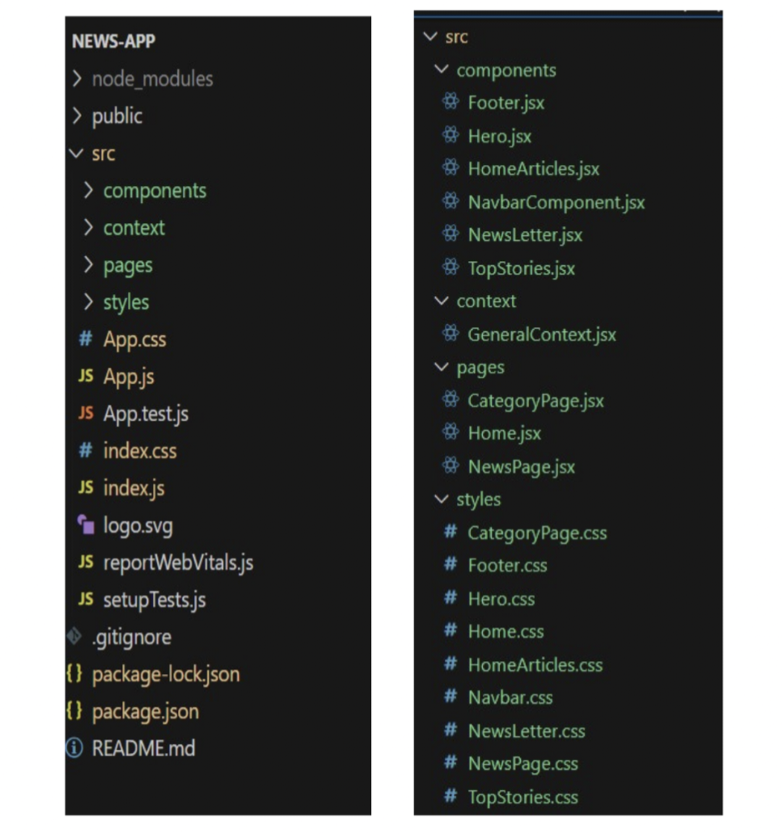

**Running the Application**

To start the frontend server locally, run the following command:

npm start

This will launch the application at http://localhost:3000/.

## ****Component Documentation****

### ****Key Components****

* **Navbar:** Provides navigation links.
* **Hero Section:** Displays top news headlines.
* **Category Section:** Fetches and displays categorized news.
* **Search Bar:** Allows users to search for news articles.
* **Footer:** Contains links and a subscription option.

### ****Reusable Components****

* **Button Component:** Customizable button with different styles.
* **Card Component:** Displays news articles in an organized manner.

## ****State Management****

### ****Global State****

* **Context API** is used to store and manage application-wide data such as user preferences and news categories.

### ****Local State****

* **useState Hook** is used for managing component-specific state such as search input values and form submissions.

## ****User**** Interface

## 

## ****Styling****

### ****CSS Frameworks/Libraries****

* **Tailwind CSS** for a modern and responsive design.
* **React Icons** for icons.

### ****Theming****

The application supports light and dark themes using **CSS variables and Tailwind utilities**.

## ****Testing****

### ****Testing Strategy****

* **Unit Testing:** Uses Jest and React Testing Library.
* **Integration Testing:** Tests interactions between multiple components.
* **End-to-End Testing:** Ensures the complete application workflow functions correctly.

### ****Code Coverage****

Coverage reports are generated using Jest and analyzed to ensure a high-quality codebase.

## ****Demo****

### ****DemoLink:****(https://drive.google.com/file/d/1srKvkCfA285clIlJGePqLZdMZi9RsK_X/view?usp=drivesdk)

## ****Known Issues****

### ****Current Bugs****

* Some API requests may fail due to rate limits.
* Search functionality needs optimization for better accuracy.

**Future Enhancements**

* **AI-powered news recommendations** based on user preferences.
* **Offline mode** for accessing previously loaded articles.
* **Push notifications** for breaking news alerts.
* **More categories and regional news filters**.

**Happy Coding! 🚀**